# **TrashCan**

**Application to segregate Recyclable Waste using Deep Learning**

A PROJECT REPORT

By

**Naman Jain (RA1911003010090)**

**Suvodeep Sinha (RA1911003010108)**

Under the supervision of

### **Dr. S. Babu**

*In partial fulfillment for the Course*

of

18CSP107L: MINOR PROJECT

in

Computer Science and Engineering



### **FACULTY OF ENGINEERING AND TECHNOLOGY SRM INSTITUTE OF SCIENCE AND TECHNOLOGY**

**Kattankulathur, Chengalpattu District**

September 2022

**SRM INSTITUTE OF SCIENCE AND TECHNOLOGY**

**(Under Section 3 of UGC Act, 1956)**

**BONAFIDE CERTIFICATE**

Certified that this project report titled “**TrashCan**” is the bonafide work of “**Naman Jain (RA1911003010090)**”, **Suvodeep Sinha (RA1911003010108),** who carried out the project work under my supervision. Certified further, that to the best of my knowledge the work reported herein does not form any other project report or dissertation on the basis of which a degree or award was conferred on an earlier occasion on this or any other candidate.

| **Signature** | **Signature** |
| --- | --- |
| Dr. S. Babu  **Supervisor and Panel Head**  Associate Professor  Department of Computing Technologies | Dr. M. Pushpalatha, Ph.D.  **Head Of The Department**  Department of Computing Technologies,  SRM Institute of Science and Technology |
| Signature of the Internal Examiner | Signature of the Internal Examiner |

### **Acknowledgments**

We would like to express our deepest gratitude to our guide,

Dr. S. Babu his valuable guidance, consistent encouragement, personal caring, timely help, and for providing us with an excellent atmosphere for doing research. All through the work, in spite of his busy schedule, he has extended cheerful and cordial support to us for completing this project work.

**Naman Jain**

**Suvodeep Sinha**

### 

### **Abstract**

In 2021, India currently ranks 155 out of 180 countries in the environmental performance index. This is due to poor handling of waste management and pollution. With the emergence of several government schemes such as “Swachh Bharat Abhiyan” and “Smart Cities Mission”, there has been a surge in both garbage production and its collection. But, there is zero effort to segregate the waste.

A major part of segregation is still dependent on manual labor which is slow and inefficient. Hence, we propose an automated way to segregate waste into recyclable and non-recyclable components using Deep Learning(Convolutional Neural Networks) embedded into a Mobile Application.

### **Table Of Contents**

| Acknowledgements | iii |
| --- | --- |
| Abstract | iv |

| 1. | Introduction | | 6 |
| --- | --- | --- | --- |
|  | 1.1 | Problem Statement | 6 |
|  | 1.2 | Objectives | 6 |
|  | 1.3 | Challenges to Address | 6 |
| 2. | Literature Survey | | 7 |
|  | 2.1 | Literature Review | 7 |
|  | 2.2 | Comparison of Existing Methods | 7 |
| 3. | System Architecture | | 9 |
|  | 3.1 | Architecture Diagram | 9 |
|  | 3.2 | Flow Diagram | 10 |
| 4. | Module Description and Implementation | | 11 |
| 5. | Intermediate Results and Discussion | | 13 |
| 6. | Screenshots | | 14 |
| 7. | References | | 15 |

**Introduction**

**1.1 Problem Statement**

Segregation and management of waste have been a longstanding issue that has impacted a vast percentage of the ecosystem. It is easier to manage waste using today’s technology if they are applied properly.

We found that most available datasets classify garbage into a few classes (2 to 6 classes at most). Despite that, among all the previously explored options, the highest accuracy achieved was 79.94% with CNN and (SVM as last layer) using partial data augmentation. However, no matter what techniques which were added on, it was extremely hard to break through the 80% threshold with the scratch model.

**1.2 Objectives**

We plan to use image classification techniques on a dataset of 15000+ images consisting of different types of waste. The system will be tested on real images taken by the user within the intended usage environment through our mobile application. After processing the images, the application will correctly classify the waste as recyclable or not for the benefit of the user.

We plan to achieve this by using a diverse dataset and software tools like Tensorflow, Python, Flask, Android Studio, and Flutter.

**1.3 Challenges to Address**

* Garbage Recycling is a key aspect of preserving our environment. To make the recycling process possible/easier, the garbage must be sorted into groups that have similar recycling processes.
* We found that most available datasets classify garbage into a few classes (2 to 6 classes at most).
* Being able to classify the images into more classes is a big step towards improving the recycling process by increasing the percentage of recycled garbage.

**Literature Survey**

**2.1 Literature Review**

A literature review is a piece of academic writing demonstrating knowledge and understanding of the academic literature on a specific topic placed in context.

We have looked through approximately 10 research papers with topics or concepts related to our project. Focusing on different aspects of these papers was useful to help plan, develop, refine and write a comparative analysis of the whole corpus.

**2.2 Comparison of Existing Methods**

| Title | Approach and Algorithm | Accuracy | Notable Achievements | Remarks |
| --- | --- | --- | --- | --- |
| [A Method for Waste Segregation using](https://arxiv.org/pdf/2202.12258.pdf)  [CNN](https://arxiv.org/pdf/2202.12258.pdf) | Comparison between VGG 16, ResNet, AlexNet | 94.9 % (ResNet-50) | 25,077 images were used in the dataset  Compilation of various techniques over the years | Segregation based on only 2 categories - Organic and Recyclable |
| [Trash Classification Using CNN - Stanford University](https://cs230.stanford.edu/projects_spring_2020/reports/38847029.pdf) | CNN with last 2 layers replaced by a classifier (softmax or SVM) | 79.94 %  (AlexNet with SVM as the last layer) | Clear and simple implementation of only 2 methods  Less computation power required | Categories are limited to 6  Sample size of the dataset is only 2527 |
| [A deep learning approach based hardware solution to](https://link.springer.com/content/pdf/10.1007/s40747-021-00529-0.pdf) categorise  [garbage in environment](https://link.springer.com/content/pdf/10.1007/s40747-021-00529-0.pdf) | InceptionNet Neural Network Architecture using a Real-time embedded system | 96.2 %  (Inception Net) | Implemented hardware solution consisting of Raspberry Pi, IR sensor and PI Camera | Only 6 classes are used to categorize garbage |
| [Waste Segregation Using Deep Learning](http://www.joics.org/gallery/ics-3683.pdf) | Zero Shot Learning and Object Detection Algorithms | 83.60 % (YOLOv3) | Unique approach to task  Algorithm mentioned clearly with plans of proposed system | Focus on Object Detection rather than classification  Trained on COCO Dataset |
| [Xception: Deep Learning with Depth Wise Separable Convolutions](https://arxiv.org/pdf/1610.02357.pdf) | Improvement on InceptionNet | —------ | Xception significantly outperforms Inception V3 on a larger image classification dataset comprising 350 million images and 17,000 classes. | The performance gains are not due to increased capacity but rather to more efficient use of model parameters. |
| [Intelligent Waste Classification System Using Deep Learning CNN](https://www.sciencedirect.com/science/article/pii/S2351978919307231) | CNN(Alexnet) with last 2 layers replaced by a classifier | 85 % (AlexNet with SVM as the last layer) | Takes care of overfitting with dropout layer | Limited to only 4 different categories  Small dataset of 1989 images |
| [Classification](https://cs229.stanford.edu/proj2016/report/ThungYang-ClassificationOfTrashForRecyclabilityStatus-report.pdf)  [of Trash for Recyclability Status - Stanford University](https://cs229.stanford.edu/proj2016/report/ThungYang-ClassificationOfTrashForRecyclabilityStatus-report.pdf) | SVM with SIFT features  CNN with Torch7 framework | 63 % (SVM) | Use of a simpler algorithm as SVM  Implemented an eleven layer  CNN that is very similar to AlexNet | Small dataset of 2527 images  DIfferentiated on the basis of 6 classes |
| [Classification of TrashNet Dataset Based on Deep Learning Models](https://ieeexplore.ieee.org/document/8622212) | Inception Resnet V2, Xception architectures | 94 % (Inception Resnet V2) | Adam and Adadelta were used as the optimizer in neural network models | Limited samples of the Trashnet dataset |

**System Architecture**

**3.1 Architecture Diagram**

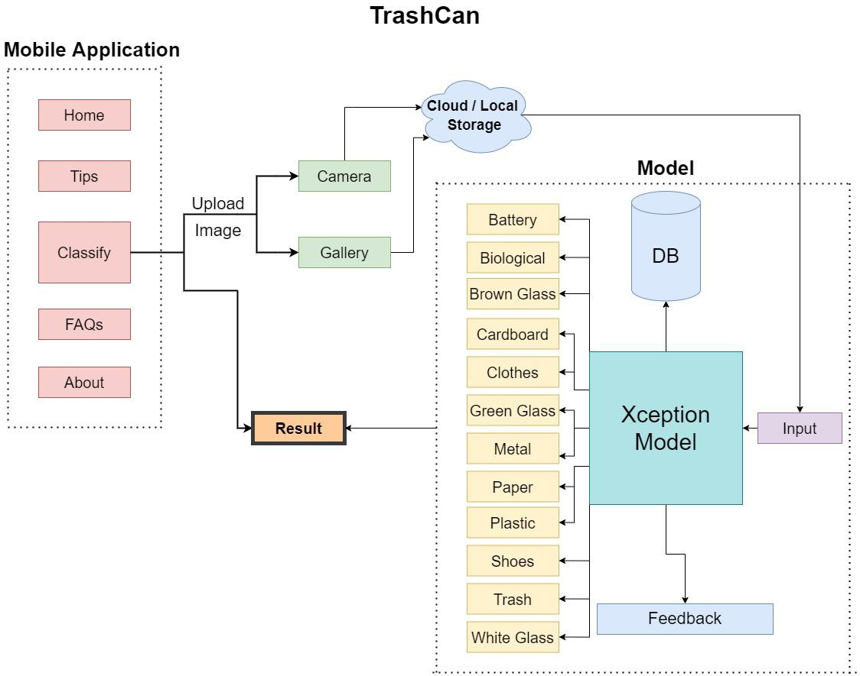

**3.2 Flow Diagram**

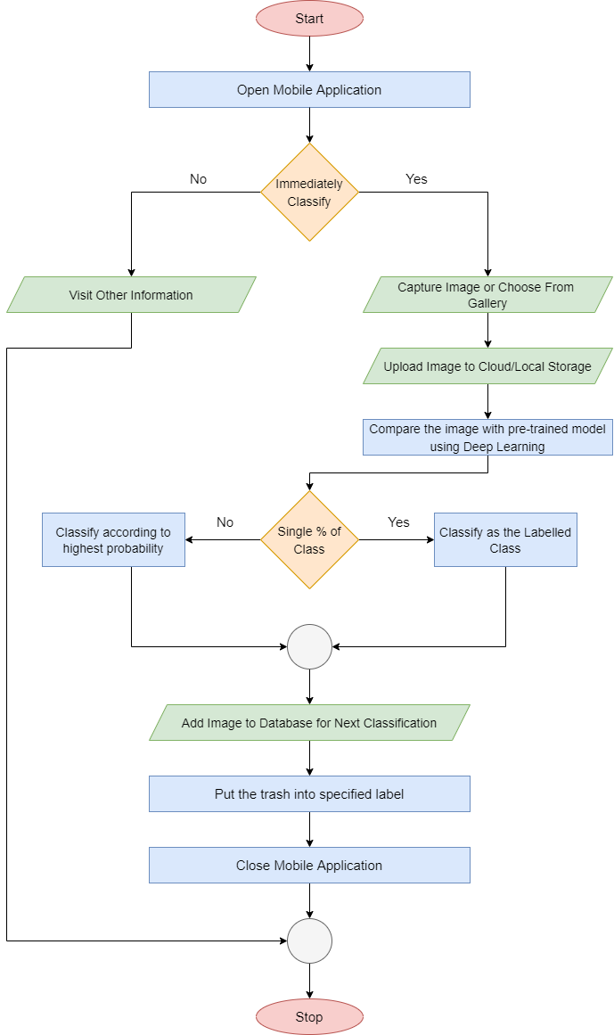

**Module Description and Implementation**

### 

* Defining Categories and Parameters

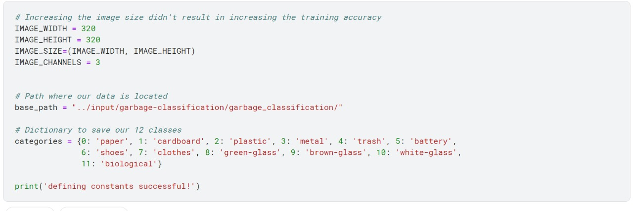

* Cleaning Data

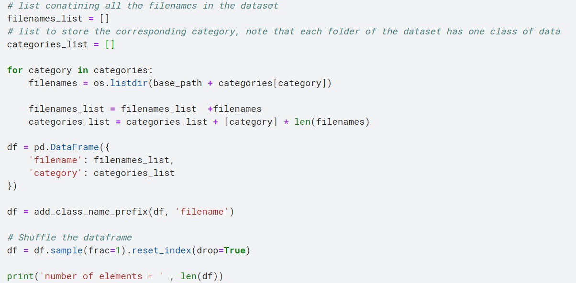

* Visualizing Data

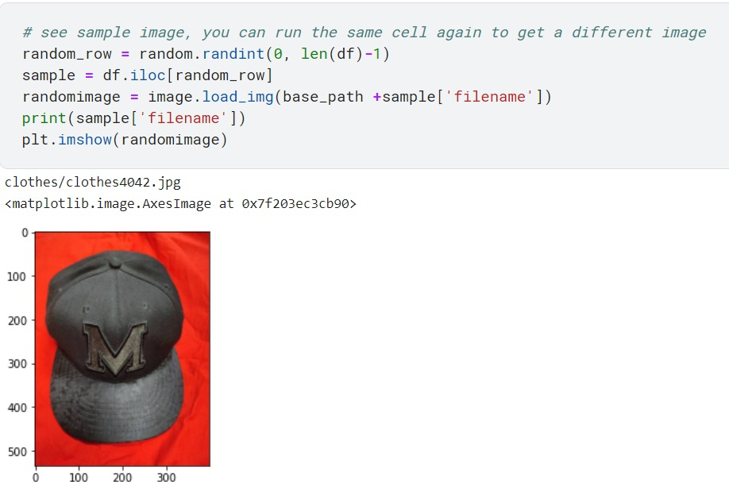

**Intermediate Result and Discussions**

* Category Distribution

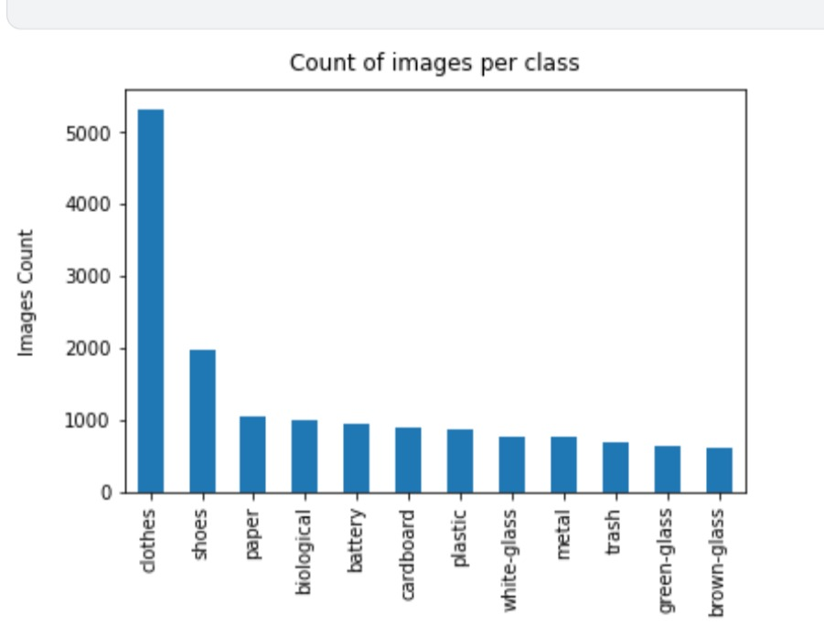

* Model Structure

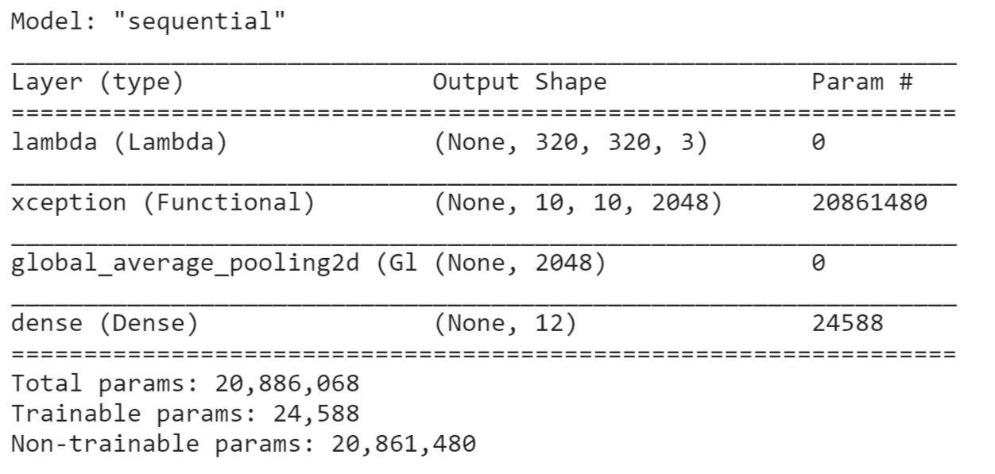

**Screenshots**

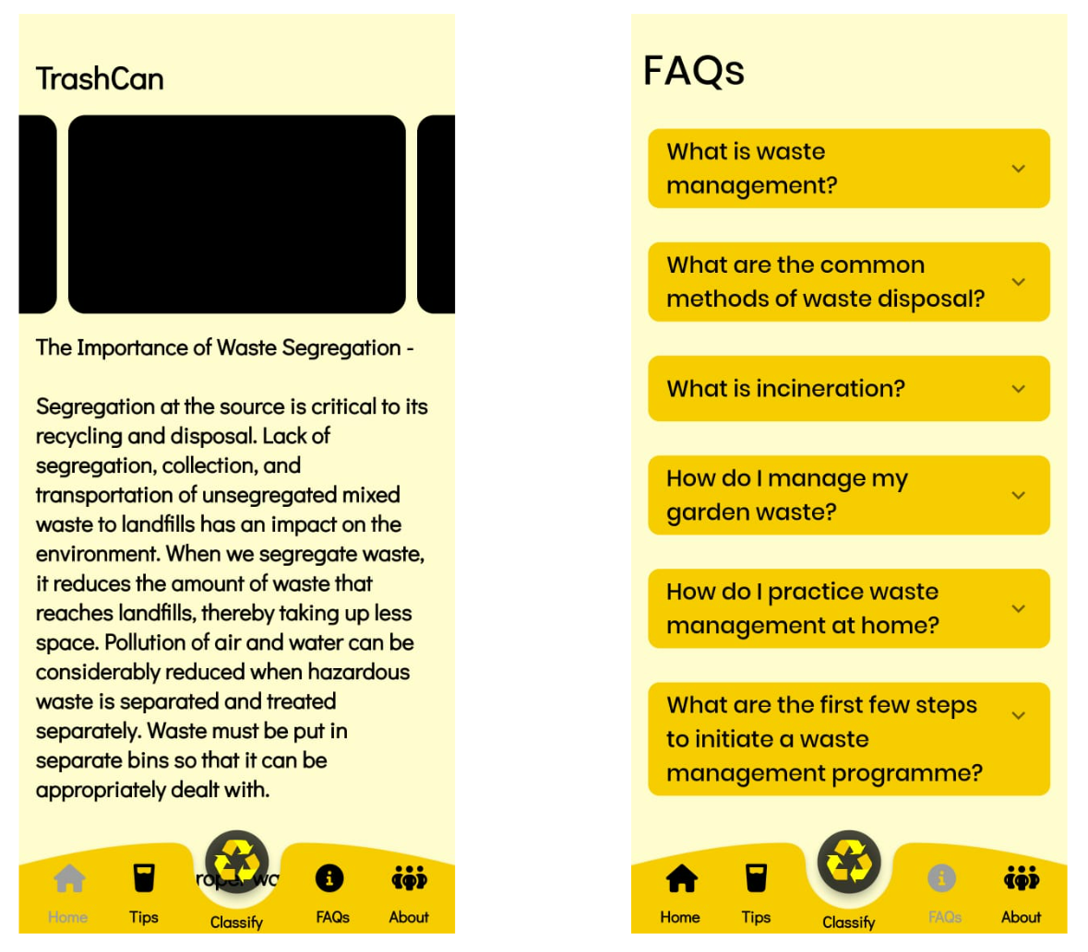

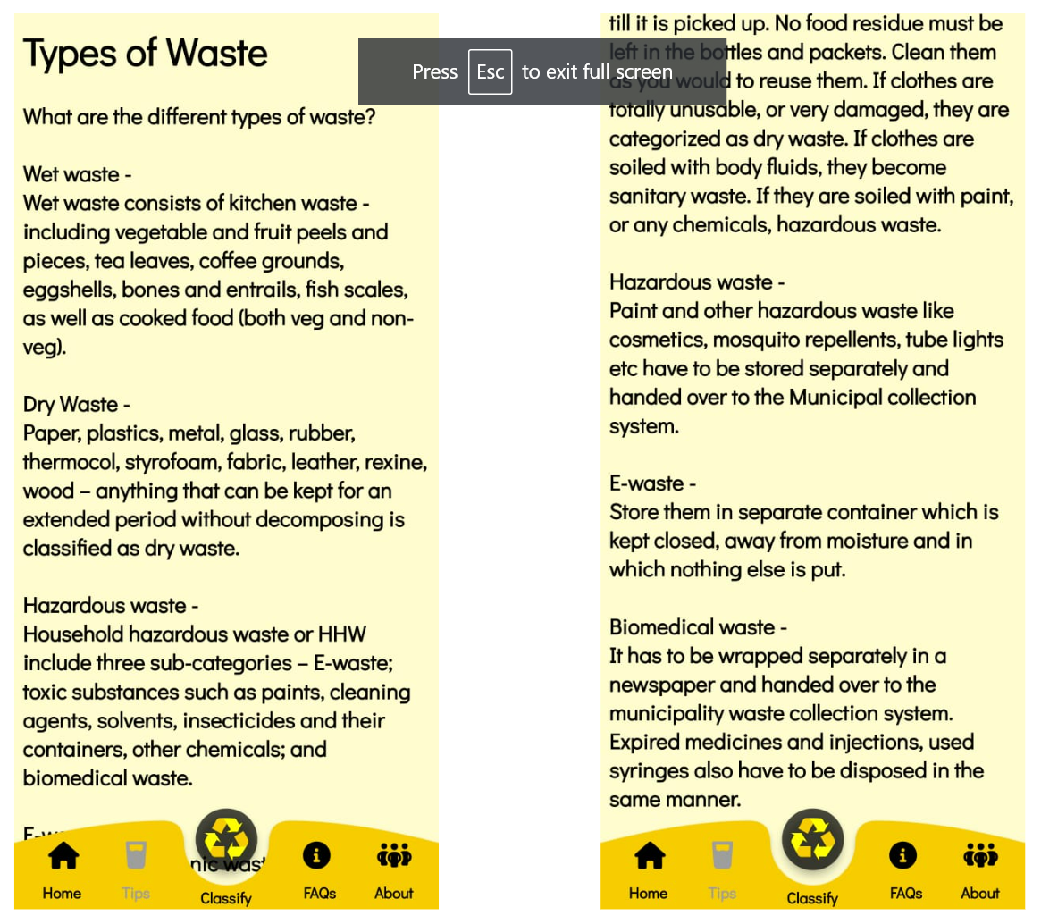

**References**

* F. Chollet. Keras. <https://github.com/fchollet/keras>, 2015. [3] D.-A. Clevert, T. Unterthiner, and S. Hochreiter. Fast and accurate deep network learning by exponential linear units (elus). arXiv preprint arXiv:1511.07289, 2015.
* <https://link.springer.com/content/pdf/10.1007/s40747-021-00529-0.pdf>
* Chu Y, Huang C, Xie X, Tan B, Kamal S, Xiong X (2018) Multilayer hybrid deep-learning method for waste classification and recycling. Comput Intell Neurosci
* Github | “Trashnet waste repository”. [https://github.com/ garythung/trashnet](https://github.com/)

* Sekar S. Waste classification data. Kaggle, 16 June 2019, [www. kaggle.com/techsash/waste-classification-data](https://www.kaggle.com/techsash/waste-classification-data)
* Serezhkin A. Drinking waste classification. Kaggle, 10 May, 2020, [www.kaggle.com/arkadiyhacks/drinking-waste-classification](http://www.kaggle.com/arkadiyhacks/drinking-waste-classification)